Barbiturates Test BARB0110



Benzylpiperazine Test BZ0110



BMK PMK Test BMKPMK0270-1



Buprenorphine Test BUPR0270



Cannabis Test CA0110

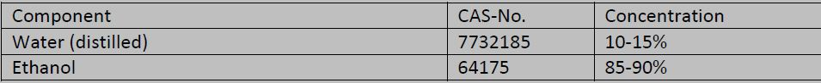

Cocaine Crack Test COC0110



Cocaine Odour Test COCOD0110



Crystal Meth-XTC Test METAM0110



Dried Qat Test DC0110

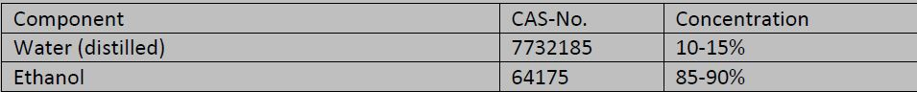

Ephedrine Test EPHE0110-1



Fent-Oxy, Her-Morph, Cod Test FOHM0110



Fresh Qat Test FQ0110

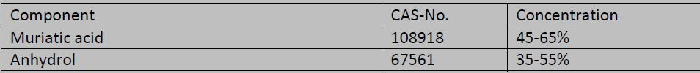

GBL Test GBL0110-1

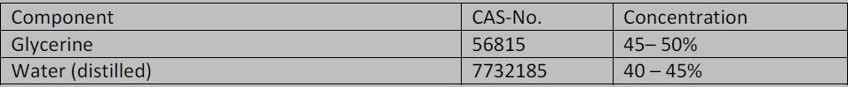

General Screening Test GS0110



GHB Test GHB0110

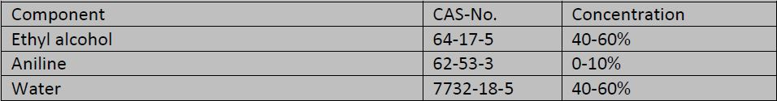

Heroin Test HER0110



Ketamine Test KETA0110



LSD Test

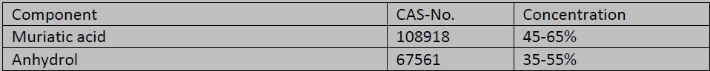

M&H Test MH0110



MCPP0110 MCPP TEST



Mephedrone Test MEPH0110

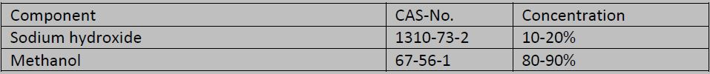

Methadone Test METH0110



Methaqualone Test METQ0110



Opiates-Amfetamines Test OPA0110



PCP Test PCP0110

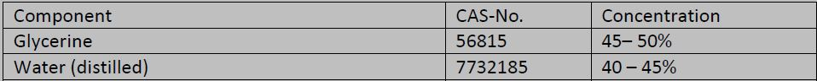

Pentazocine Test PENTA0110



Phenetylamines Test PHENET0110



Prime Test PRI0110

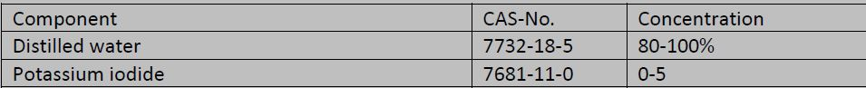

Propoxyphene Test PPX0110



Psilocybin Test PSI0110

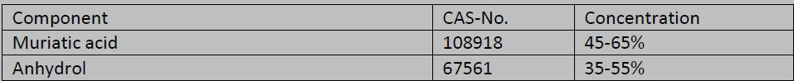

Synthetic Cannabinoids Test SCA0110



Synthetic Cathinones Test SCT0110

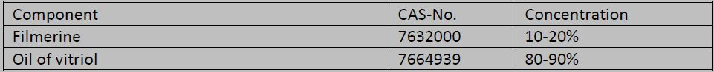

V&R Test VR0110

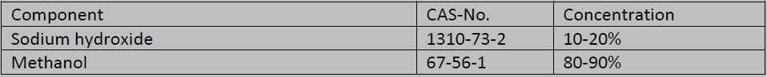

LSD/Psychedelics New Test

Chemichal Name Conc. CAS No.

Hydrochloric Acid 50 7647010

Ethanol 50 64175

Crystal Meth-XTC Test

Sulfuric Acid 96 7664939

Paraformaldehyde <4 30525894

Distilled Water <2 7732185